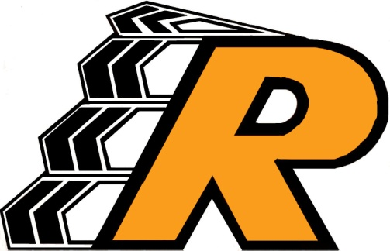
Ronan School District No. 30
Ronan / Pablo Schools
421 Andrew Street NW
Ronan, MT 59864-2302
Phone: (406) 676-3390 ext. 7200
Fax: (406) 676-3392

August 12, 2021
Parents/Guardians of Students at Ronan School District 30,
Our school district has recently adopted CKLA/Amplify as our new reading curriculum. This curriculum builds students’ knowledge of science, social studies, literature and more, while building literacy skills in rich, relevant contexts K-8. In the CKLA/Amplify curriculum, some of the content students will be learning about includes Important People in American History, Early American Civilizations, Westward Expansion, Early Explorations of North America, Columbus and the Pilgrims and Native Americans just to name a few. Through evaluating bias in literature/curriculum, a committee has found that many of these topics are described through European perspectives. Though some of this material is culturally sensitive, it is our intent to use teachable moments to supplement this material with Native American perspectives, tribally specific information/images, and content relative to our community. Though this process will not happen overnight, we will continue to work on this project to ensure students have the best opportunity to learn about their culture and history, as well as giving teachers the appropriate tools to teach this material. It is a priority for the Ronan School District to address bias in a culturally competent way. The Indian Education for All, Essential Understandings have been used to help support our efforts. We have assembled a knowledgeable committee with members from SKC, Title VI, I.E.C. and staff from our school district to help us locate problematic content and suggest strategies to make the curriculum more inclusive. If you have questions or concerns regarding these efforts please feel free to contact any of the following people:
SKC, Tammy Elser tammy_elser@skc.edu
I.E.C. Member, Linda Ferris linda_ferris@skc.edu
Community Member, Joan Graham joan.graham@ronank12.edu
RHS IEFA Building Rep, Indian Education Coordinator, Eva Green eva.green@ronank12.edu
RMS IEFA Building Rep/RMS 8th Grade Alina Graves alina.graves@ronank12.edu
PES IEFA Building Rep /PES 3rd Grade Sunny Sifford sunny.sifford@ronank12.edu
KWH IEFA Building Rep, KWH PE, Dusti Smith dusti.smith@ronank12.edu
RMS Librarian Amy Miller amy.miller@ronank12.edu
PES Librarian Gay Speckert gay.speckert@ronank12.edu
KWH Librarian, Whitney Dumont whitney.dumont@ronank12.edu
RMS/RHS Reading Coach, Kristina Briney kristina.briney@ronank12.edu
PES Reading Coach, Erin Stephen erin.stephen@ronank12.edu
KWH Reading Coach, Crystal Cornwell crystal.cornwell@ronank12.edu
RMS Principal, Frank Jobe, frank.jobe@ronank12.edu
KWH Principal, Mike Ellis mike.ellis@ronank12.edu
Director of Curriculum, Federal Programs and Grants, Sandra Beal sandra.beal@ronank12.edu

